**USING COOKIES:**

**USING COOKIES:**

**AnimalPageServlet.java:**

import javax.servlet.ServletException;

import javax.servlet.annotation.WebServlet;

import javax.servlet.http.Cookie;

import javax.servlet.http.HttpServlet;

import javax.servlet.http.HttpServletRequest;

import javax.servlet.http.HttpServletResponse;

import java.io.IOException;

import java.io.PrintWriter;

@WebServlet("/animalPage")

public class AnimalPageServlet extends HttpServlet {

@Override

protected void doGet(HttpServletRequest request, HttpServletResponse response) throws ServletException, IOException {

String userName = null;

int visitCount = 0;

// Retrieve cookies

Cookie[] cookies = request.getCookies();

if (cookies != null) {

for (Cookie cookie : cookies) {

switch (cookie.getName()) {

case "userName":

userName = cookie.getValue();

break;

case "visitCount":

visitCount = Integer.parseInt(cookie.getValue());

break;

}

}

}

visitCount++;

Cookie visitCookie = new Cookie("visitCount", Integer.toString(visitCount));

visitCookie.setMaxAge(60 * 60 * 24); // 1 day

response.addCookie(visitCookie);

response.setContentType("text/html");

PrintWriter out = response.getWriter();

out.println("<html><body>");

out.println("<h1>Zoo Animal Page</h1>");

if (userName != null) {

out.println("<p>Welcome back, " + userName + "!</p>");

} else {

out.println("<p>Welcome to the zoo!</p>");

}

out.println("<p>Number of visits: " + visitCount + "</p>");

out.println("<form method='POST' action='animalPage'>");

out.println("Name: <input type='text' name='userName'><br>");

out.println("<input type='submit' value='Save Name'>");

out.println("</form>");

out.println("</body></html>");

}

@Override

protected void doPost(HttpServletRequest request, HttpServletResponse response) throws ServletException, IOException {

String userName = request.getParameter("userName");

if (userName != null && !userName.trim().isEmpty()) {

Cookie userCookie = new Cookie("userName", userName);

userCookie.setMaxAge(60 * 60 * 24 * 30); // 30 days

response.addCookie(userCookie);

}

response.sendRedirect("animalPage");

}

}

**WEB.XML:**

<web-app xmlns="http://java.sun.com/xml/ns/javaee"

xmlns:xsi="http://www.w3.org/2001/XMLSchema-instance"

xsi:schemaLocation="http://java.sun.com/xml/ns/javaee

http://java.sun.com/xml/ns/javaee/web-app_4_0.xsd"

version="4.0">

<!-- Servlet for Home Page -->

<servlet>

<servlet-name>HomePageServlet</servlet-name>

<servlet-class>com.zoo.HomePageServlet</servlet-class>

</servlet>

<servlet-mapping>

<servlet-name>HomePageServlet</servlet-name>

<url-pattern>/homePage</url-pattern>

</servlet-mapping>

<!-- Servlet for Zoo Page (Where user interacts with cookies) -->

<servlet>

<servlet-name>ZooPageServlet</servlet-name>

<servlet-class>com.zoo.ZooPageServlet</servlet-class>

</servlet>

<servlet-mapping>

<servlet-name>ZooPageServlet</servlet-name>

<url-pattern>/zooPage</url-pattern>

</servlet-mapping>

<!-- Servlet for Changing Theme -->

<servlet>

<servlet-name>ThemeServlet</servlet-name>

<servlet-class>com.zoo.ThemeServlet</servlet-class>

</servlet>

<servlet-mapping>

<servlet-name>ThemeServlet</servlet-name>

<url-pattern>/theme</url-pattern>

</servlet-mapping>

</web-app>

index.html :

<!DOCTYPE html>

<html lang="en">

<head>

<meta charset="UTF-8">

<meta name="viewport" content="width=device-width, initial-scale=1.0">

<title>Zoo Welcome Page</title>

<style>

body {

background-image: url("zoo.jpg");

background-size: cover;

font-family: Arial, sans-serif;

font-size: xx-large;

}

.container {

text-align: center;

padding: 50px;

}

.title {

font-size: 2.5em;

color: #1c0912;

margin-bottom: 20px;

}

.link-button {

display: inline-block;

padding: 15px 25px;

font-size: 1.2em;

color: white;

background-color: #e12c87;

text-decoration: none;

border-radius: 5px;

margin-top: 20px;

}

.link-button:hover {

background-color: #ff1493;

}

</style>

</head>

<body>

<div class="container">

<div class="title">Welcome to Our Zoo!</div>

<a href="animalPage" class="link-button">Enter Zoo Animal Page</a>

</div>

</body>

</html>

**OUTPUT:**

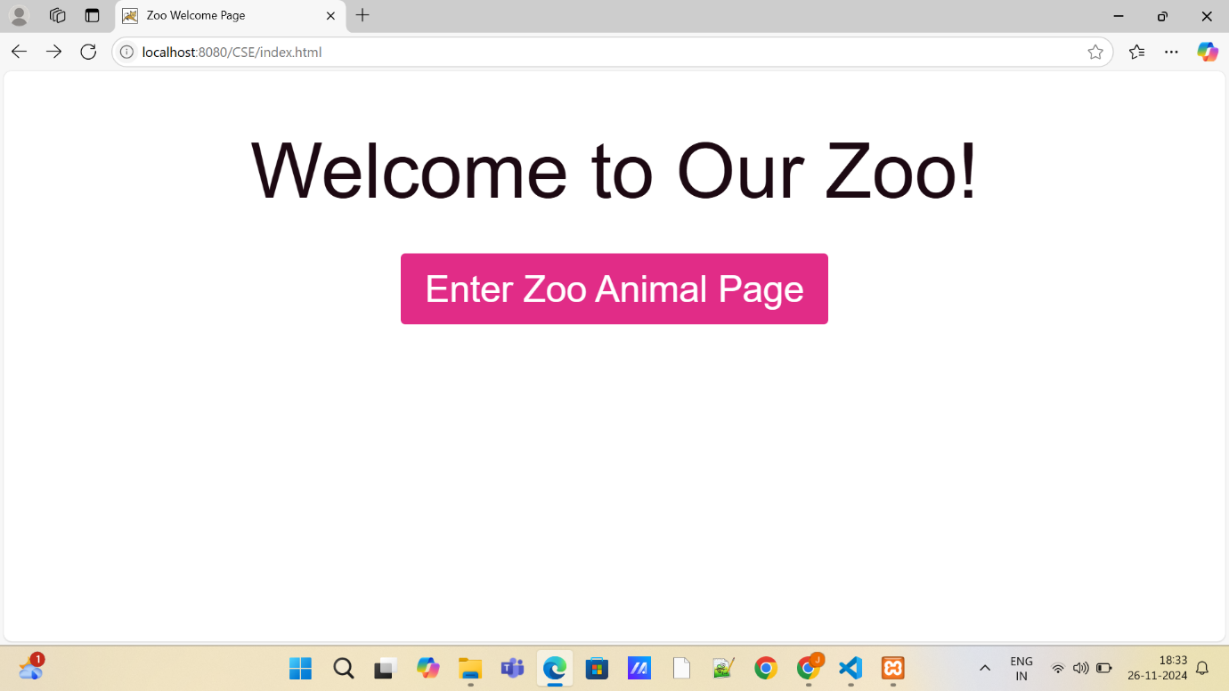

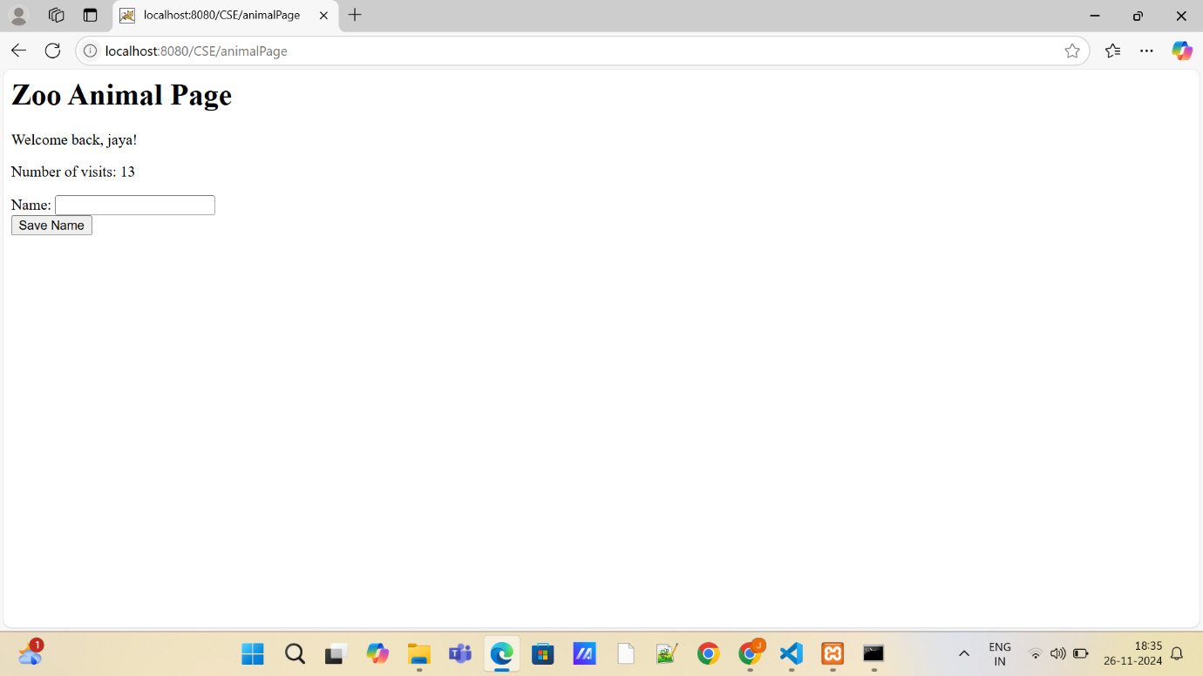

**HTTP SESSION:**

**ZooSessionServlet.java:**

import javax.servlet.ServletException;

import javax.servlet.annotation.WebServlet;

import javax.servlet.http.HttpServlet;

import javax.servlet.http.HttpServletRequest;

import javax.servlet.http.HttpServletResponse;

import javax.servlet.http.HttpSession;

import java.io.IOException;

import java.io.PrintWriter;

@WebServlet("/zooSession")

public class ZooSessionServlet extends HttpServlet {

    @Override

    protected void doGet(HttpServletRequest request, HttpServletResponse response) throws ServletException, IOException {

        HttpSession session = request.getSession(true);

        String userName = (String) session.getAttribute("userName");

        Integer visitCount = (Integer) session.getAttribute("visitCount");

        if (visitCount == null) {

            visitCount = 0;

        }

        visitCount++;

        session.setAttribute("visitCount", visitCount);

        response.setContentType("text/html");

        PrintWriter out = response.getWriter();

        out.println("<html><body>");

        out.println("<h1>Zoo Animal Page</h1>");

        if (userName != null) {

            out.println("<p>Welcome back, " + userName + "!</p>");

        } else {

            out.println("<p>Welcome to the zoo!</p>");

        }

        out.println("<p>Number of visits: " + visitCount + "</p>");

        out.println("<form method='POST' action='zooSession'>");

        out.println("Name: <input type='text' name='userName'><br>");

        out.println("<input type='submit' value='Save Name'>");

        out.println("</form>");

        out.println("</body></html>");

    }

    @Override

    protected void doPost(HttpServletRequest request, HttpServletResponse response) throws ServletException, IOException {

        HttpSession session = request.getSession(true);

        String userName = request.getParameter("userName");

        if (userName != null && !userName.trim().isEmpty()) {

            session.setAttribute("userName", userName);

        }

        response.sendRedirect("zooSession");

    }

}

**OUTPUT:**

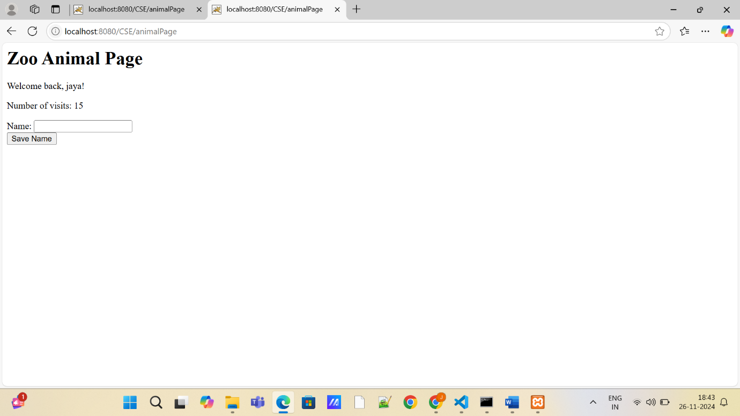

**URL REWRITING:**

**ZooURLRewritingServlet.java**

import javax.servlet.ServletException;

import javax.servlet.annotation.WebServlet;

import javax.servlet.http.HttpServlet;

import javax.servlet.http.HttpServletRequest;

import javax.servlet.http.HttpServletResponse;

import java.io.IOException;

import java.io.PrintWriter;

@WebServlet("/zooPage")

public class ZooURLRewritingServlet extends HttpServlet {

    @Override

    protected void doGet(HttpServletRequest request, HttpServletResponse response) throws ServletException, IOException {

        String userName = request.getParameter("userName");

        String visitCountStr = request.getParameter("visitCount");

        int visitCount = 0;

        if (visitCountStr != null && !visitCountStr.isEmpty()) {

            visitCount = Integer.parseInt(visitCountStr);

        }

        visitCount++;

        response.setContentType("text/html");

        PrintWriter out = response.getWriter();

        out.println("<html><body>");

        out.println("<h1>Zoo Animal Page</h1>");

        if (userName != null) {

            out.println("<p>Welcome back, " + userName + "!</p>");

        } else {

            out.println("<p>Welcome to the zoo!</p>");

        }

        out.println("<p>Number of visits: " + visitCount + "</p>");

        out.println("<form method='POST' action='zooPage'>");

        out.println("Name: <input type='text' name='userName' value='" + (userName != null ? userName : "") + "'><br>");

        out.println("<input type='hidden' name='visitCount' value='" + visitCount + "'>");

        out.println("<input type='submit' value='Save Name'>");

        out.println("</form>");

        out.println("</body></html>");

    }

    @Override

    protected void doPost(HttpServletRequest request, HttpServletResponse response) throws ServletException, IOException {

        String userName = request.getParameter("userName");

        String visitCountStr = request.getParameter("visitCount");

        int visitCount = Integer.parseInt(visitCountStr);

        String url = "zooPage?userName=" + userName + "&visitCount=" + visitCount;

        response.sendRedirect(url);

    }

}

**OUTPUT:**

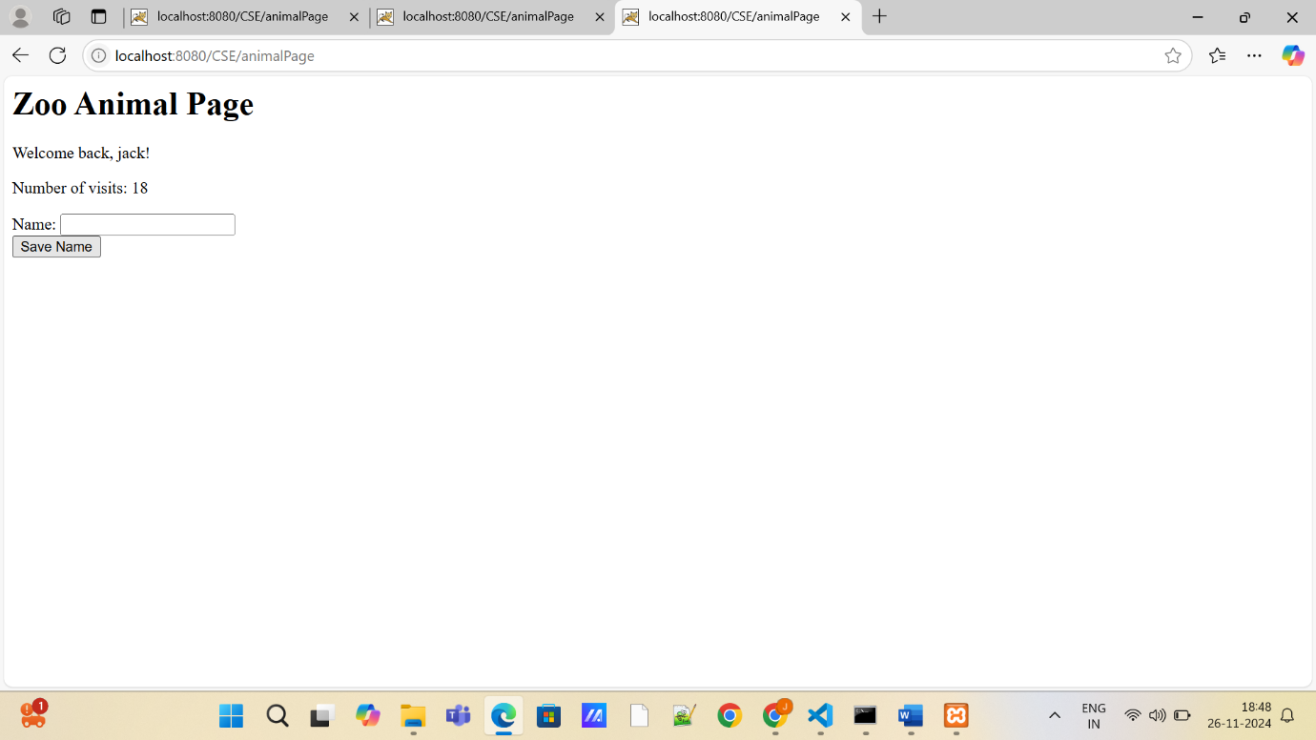

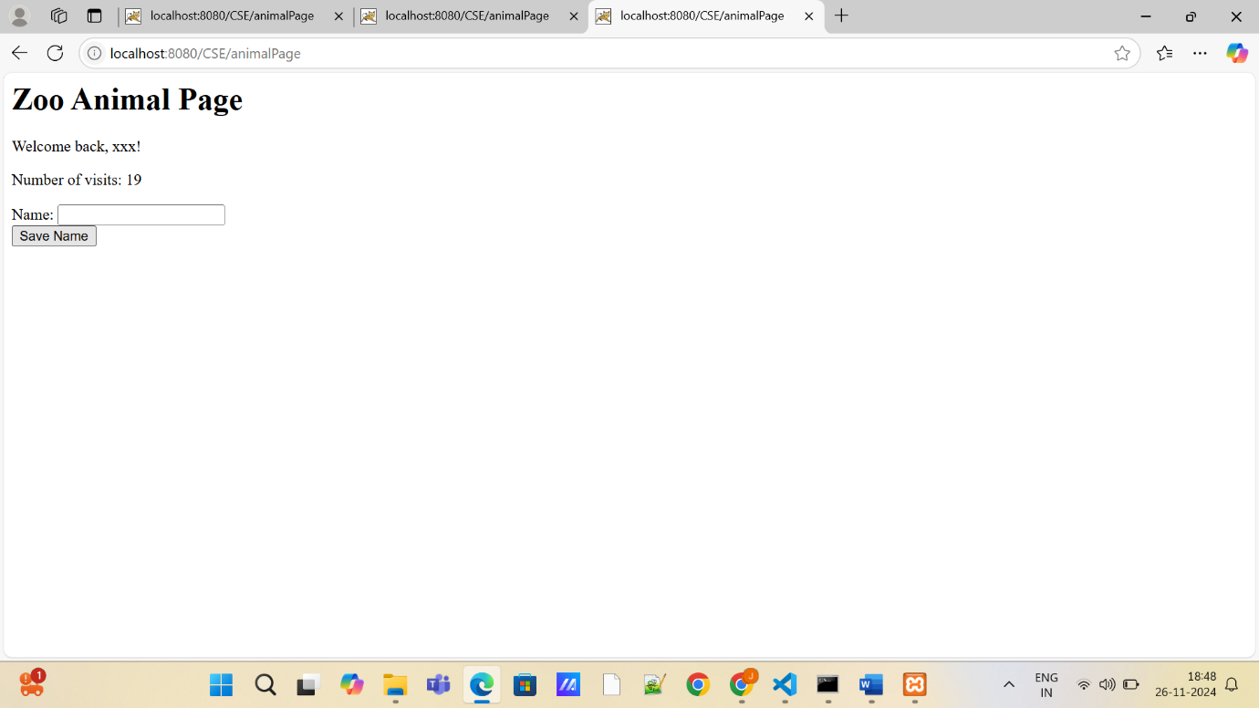

**HIDDEN FORM FIELDS:**

**ZooHiddenFieldsServlet.java**

**import javax.servlet.ServletException;**

**import javax.servlet.annotation.WebServlet;**

**import javax.servlet.http.HttpServlet;**

**import javax.servlet.http.HttpServletRequest;**

**import javax.servlet.http.HttpServletResponse;**

**import java.io.IOException;**

**import java.io.PrintWriter;**

**@WebServlet("/zooHiddenPage")**

**public class ZooHiddenFieldsServlet extends HttpServlet {**

**@Override**

**protected void doGet(HttpServletRequest request, HttpServletResponse response) throws ServletException, IOException {**

**// Retrieve parameters from hidden fields in the URL**

**String userName = request.getParameter("userName");**

**String visitCountStr = request.getParameter("visitCount");**

**int visitCount = 0;**

**// Initialize the visit count to 0 if not present in the request**

**if (visitCountStr != null && !visitCountStr.isEmpty()) {**

**visitCount = Integer.parseInt(visitCountStr);**

**}**

**// Increment the visit count**

**visitCount++;**

**// Set content type and initialize PrintWriter for generating the response**

**response.setContentType("text/html");**

**PrintWriter out = response.getWriter();**

**// Generate the HTML page to display the user information and visit count**

**out.println("<html><body>");**

**out.println("<h1>Zoo Themed Page</h1>");**

**// If the userName exists, display a welcome message with the user's name**

**if (userName != null) {**

**out.println("<p>Welcome back, " + userName + "!</p>");**

**} else {**

**out.println("<p>Welcome to our zoo page!</p>");**

**}**

**// Display the visit count**

**out.println("<p>Number of visits: " + visitCount + "</p>");**

**// Form for user to input their name and submit it along with the visit count**

**out.println("<form method='POST' action='zooHiddenPage'>");**

**out.println("Name: <input type='text' name='userName' value='" + (userName != null ? userName : "") + "'><br>");**

**// Hidden form fields to store the visit count**

**out.println("<input type='hidden' name='visitCount' value='" + visitCount + "'>");**

**out.println("<input type='submit' value='Save Name and Visit Count'>");**

**out.println("</form>");**

**out.println("</body></html>");**

**}**

**@Override**

**protected void doPost(HttpServletRequest request, HttpServletResponse response) throws ServletException, IOException {**

**// Get the parameters submitted by the user via POST method**

**String userName = request.getParameter("userName");**

**String visitCountStr = request.getParameter("visitCount");**

**int visitCount = 0;**

**// Convert the visit count string to an integer if it's not null or empty**

**if (visitCountStr != null && !visitCountStr.isEmpty()) {**

**visitCount = Integer.parseInt(visitCountStr);**

**}**

**// Redirect to the same page with userName and visitCount as query parameters**

**String url = "zooHiddenPage?userName=" + userName + "&visitCount=" + visitCount;**

**response.sendRedirect(url);**

**}**

**}**